CONTEXT DIAGRAM:

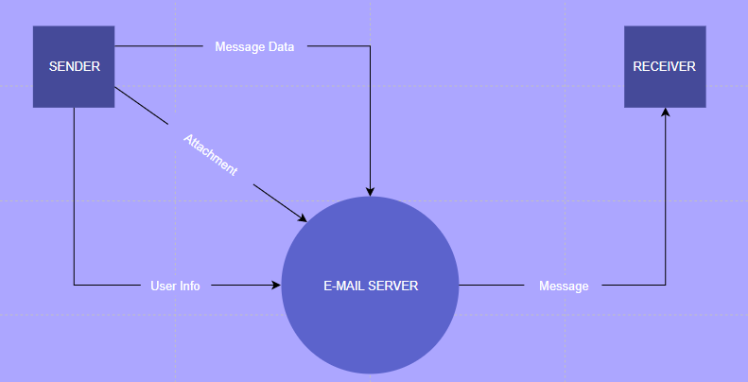

USE CASE DIAGRAM:

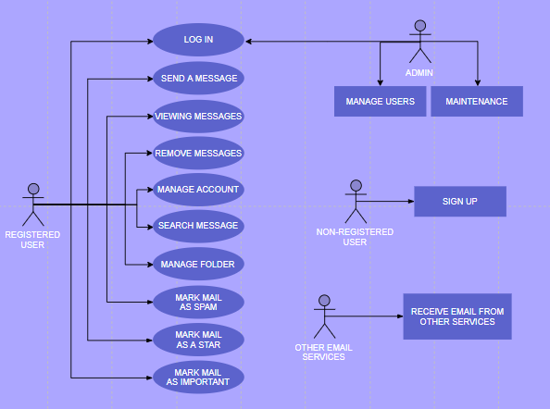

SEQUENCE DIAGRAM FOR “DELETE MAIL”:

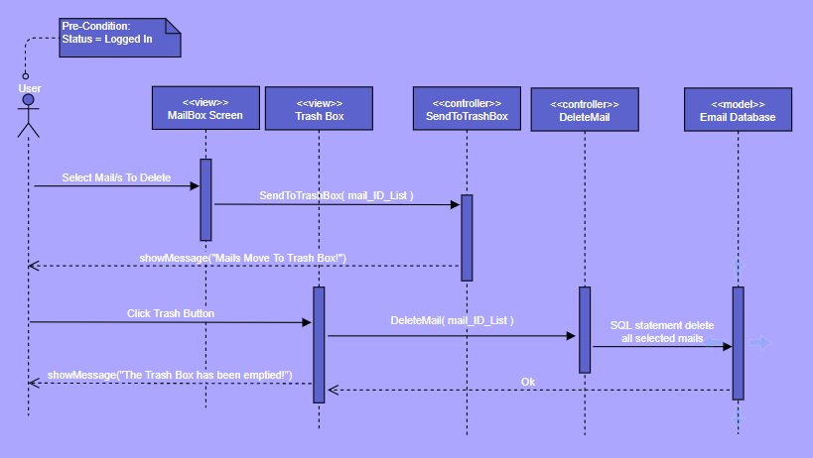

SEQUENCE DIAGRAM FOR “LOG IN”:

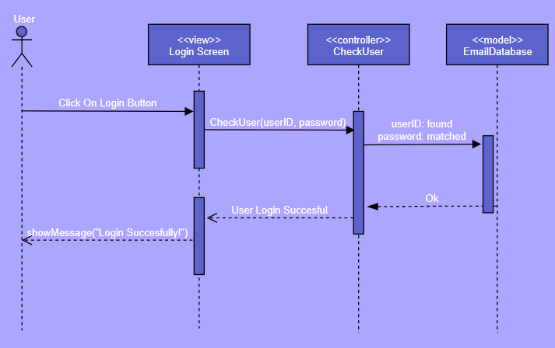

SEQUENCE DIAGRAM FOR “CHECK NEW MAILS”:

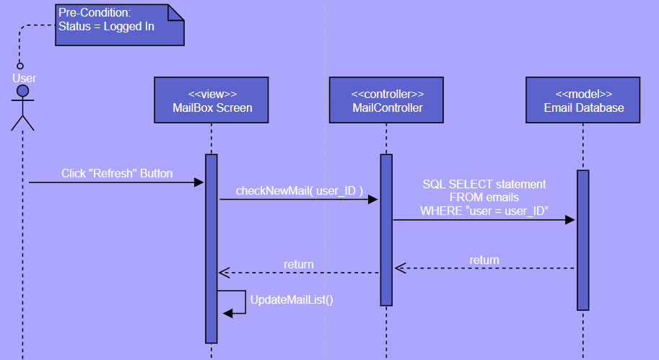

ACTIVITY DIAGRAM FOR “LOG IN”:

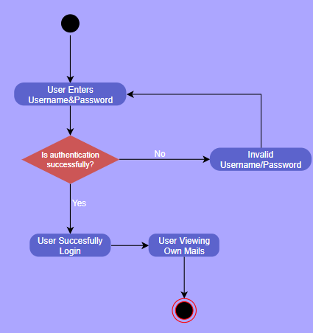

ACTIVITY DIAGRAM FOR “DELETE MAIL”:

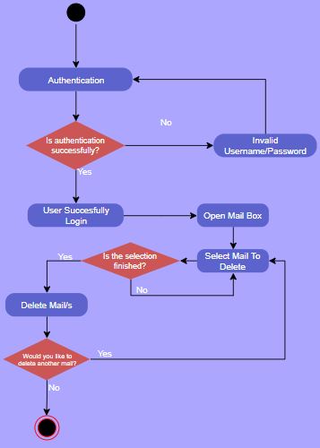

ACTIVITY DIAGRAM FOR “SEND A MAIL”:

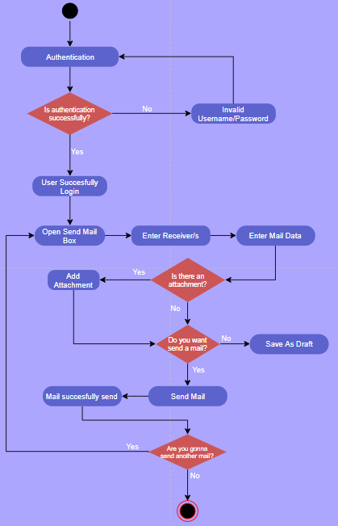

CLASS DIAGRAM:

